Processes of Memory - Retrieval
# Source: AI Source: Provided by: [Data Path: Persons Table -> ID Column: 1, Name_En Column: Motasem Essam] -> From: [ChatGPT] on [5/1/2026]
Retrieval (getting information out of memory)
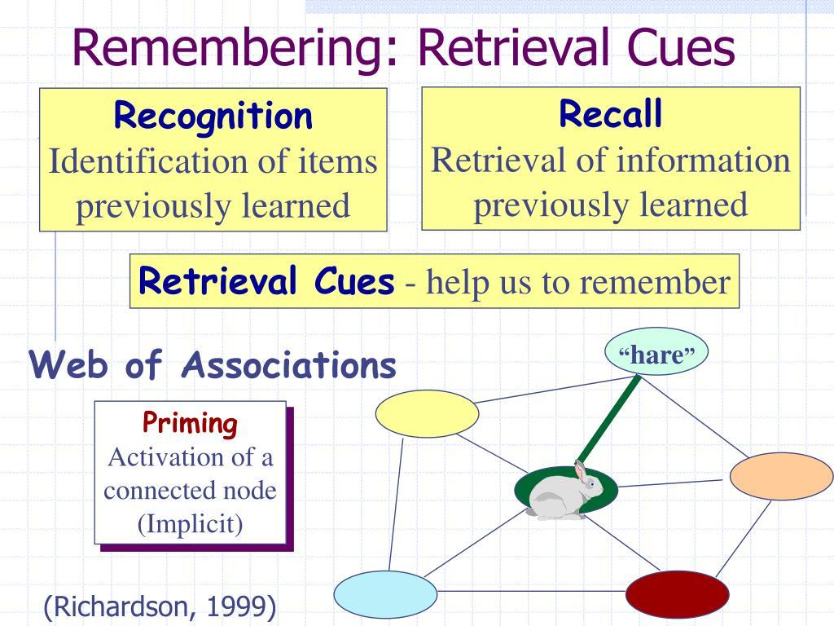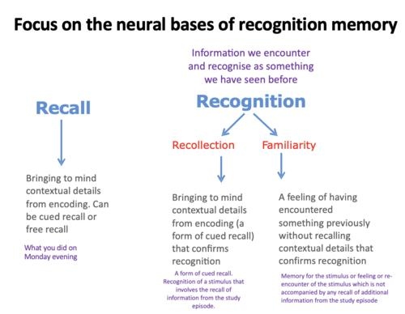
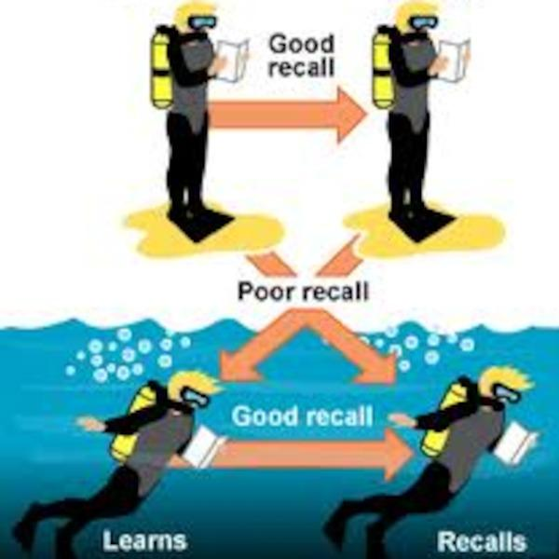
Retrieval is the process of accessing information that has been encoded and stored. In simple terms, it’s how you bring memories back into awareness when you need them.

Types of Retrieval

1. Recall
# Source: AI Source: Provided by: [Data Path: Persons Table -> ID Column: 1, Name_En Column: Motasem Essam] -> From: [ChatGPT] on [5/1/2026]
- Retrieving information without cues
- Example: answering an essay question

2. Recognition
# Source: AI Source: Provided by: [Data Path: Persons Table -> ID Column: 1, Name_En Column: Motasem Essam] -> From: [ChatGPT] on [5/1/2026]
- Identifying correct information with cues present
- Example: multiple-choice questions
- Usually easier than recall

3. Relearning
# Source: AI Source: Provided by: [Data Path: Persons Table -> ID Column: 1, Name_En Column: Motasem Essam] -> From: [ChatGPT] on [5/1/2026]
- Learning information again after forgetting it
- Faster the second time → shows the memory was still stored

Retrieval Cues (Why memory needs triggers)
# Source: AI Source: Provided by: [Data Path: Persons Table -> ID Column: 1, Name_En Column: Motasem Essam] -> From: [ChatGPT] on [5/1/2026]
Memory is often cue-dependent, meaning it works best when the right hints are available.
- Context-dependent memory
You remember better in the same environment you learned in
(shown in studies by Duncan Godden and Alan Baddeley)
- State-dependent memory
Your internal state (mood, emotions) helps retrieval
- Priming
Exposure to one stimulus influences response to another

Retrieval Failures (Why we forget)
# Source: AI Source: Provided by: [Data Path: Persons Table -> ID Column: 1, Name_En Column: Motasem Essam] -> From: [ChatGPT] on [5/1/2026]
- Cue-dependent forgetting
The memory exists, but you lack the right cue
- Interference
  - Proactive: old memories block new ones
  - Retroactive: new memories block old ones
- Tip-of-the-tongue phenomenon
You feel close to recalling something but can’t quite access it

Brain and Retrieval
# Source: AI Source: Provided by: [Data Path: Persons Table -> ID Column: 1, Name_En Column: Motasem Essam] -> From: [ChatGPT] on [5/1/2026]
- The hippocampus helps access stored memories
- The prefrontal cortex is involved in searching and selecting memories

Simple Example
# Source: AI Source: Provided by: [Data Path: Persons Table -> ID Column: 1, Name_En Column: Motasem Essam] -> From: [ChatGPT] on [5/1/2026]
During an exam:
- You may know the answer but can’t recall it (retrieval failure)
- Later, a small hint or context suddenly brings it back

Key Insight
# Source: AI Source: Provided by: [Data Path: Persons Table -> ID Column: 1, Name_En Column: Motasem Essam] -> From: [ChatGPT] on [5/1/2026]
Retrieval isn’t just “reading” memory—it’s reconstructing it.
That’s why memories can sometimes be incomplete or even inaccurate.

